PRESS RELEASE – 18 June 2018
NEW IMAGES CAN BE DOWNLOADED HERE
Twitter/ Facebook / Instagram / Website

A Frantic Assembly & Theatre Royal Plymouth production
THE UNRETURNING
- ANNA JORDAN’S NEW PLAY THE UNRETURNING WILL HAVE ITS WORLD PREMIERE AT THEATRE ROYAL PLYMOUTH ON 20 SEPTEMBER 2018 AND TOUR THE UK UNTIL 16 MARCH 2019

- DIRECTED BY NEIL BETTLES, THE CAST WILL INCLUDE JARED GARFIELD, JOE LAYTON, JONNIE RIORDAN AND KIETON SAUNDERS-BROWNE

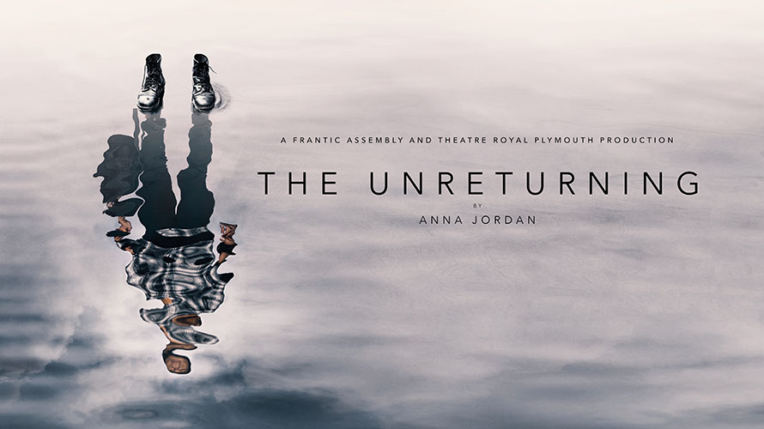

Today Frantic Assembly announces the full tour dates of The Unreturning, a brand new co-production with Theatre Royal Plymouth. Telling the interwoven stories of three men coming home from war, this new work by Bruntwood Prize for Playwriting winner Anna Jordan will be directed by Frantic Assembly associate director Neil Bettles and marks the 10th anniversary of Frantic Assembly’s award-winning Ignition training programme. The Unreturning will have its world premiere at Theatre Royal Plymouth on 20 September 2018 before playing at various venues across the UK until 16 March 2019. Additional tour dates will be announced soon.
A British northern coastal town. Three young men are coming home from war. Their stories, set at different times over the last 100 years, are beautifully interwoven in this compelling new play featuring Frantic’s celebrated physicality. The cast will include Jared Garfield, Joe Layton, Jonnie Riordan and Kieton Saunders-Browne.
The Unreturning explores the profound effect that war has on young lives, and asks - what does coming home really mean? What is home? And when experience has shattered you into a million pieces, will home help to put you together again, or treat you as an ugly truth it does not want to confront?
Ignition, which celebrates its tenth anniversary this year, is Frantic Assembly's free, national training programme for young men aged 16-20. The programme seeks out talent in unexpected places, from sports groups to youth centres, and is committed to helping young men find their individual and collective strength. No experience of the arts is necessary to participate. Frantic collaborates with regional arts partners across the UK through its Taster and Trial workshops, from which 12 of the brightest and bravest young men are selected to form the Ignition Company. They then spend five days living and working together in London where they will create an original performance with Frantic Assembly.
All four members of the cast for The Unreturning were part of the Ignition programme before they went on to train professionally and pursue acting careers.
The Unreturning will play at Theatre Royal Plymouth (20 September – 6 October), Nuffield Southampton Theatres Campus (9 – 13 October 2018), Liverpool Everyman (16 – 20 October 2018), Traverse Theatre Edinburgh (22– 27 October 2018), The Old Rep, Birmingham (30 October –2 November 2018), Theatre Royal Stratford East (16 January – 2 February 2019), Chichester Festival Theatre, Minerva (5 – 9 February 2019), Curve, Leicester (11 – 16 February 2019) and Taliesin Arts Centre (18 – 23 February 2019).
Joe Layton will play Frankie. Joe’s television work includes roles in Marvel’s Agents of S.H.I.E.L.D, Tatau (BBC Three), Casualty (BBC), Thirteen (BBC3), Father Brown (BBC) and New Worlds (C4). Joe trained at Drama Centre and made his stage debut in A Level Playing Field (Jermyn Street Theatre).
Jared Garfield will play George. Jared is best known to television audiences for his recurring role as Nathan Nightingale in Hollyoaks (C4) from 2015 to 2017. He has also appeared on television in Dr Who’s 2017 Christmas Special (BBC) and Midsomer Murders (ITV). Recent theatre roles include Mr Deville in A Harlem Dream (Young Vic), Lysander in Watch Your Head’s A Midsummer Night’s Dream (Windsor Castle) and The Dishwashers (Birmingham Rep/UK Tour). On film he has appeared in Boy A (Cuba Pictures) opposite Andrew Garfield.
Jonnie Riordon will play Nat. Jonnie is an actor, director and movement director. As an actor, he has appeared in This Will All Be Gone (Frantic Assembly, Asian tour), No Way Back (Frantic Assembly/Made in Corby), Full Stop (Light The Fuse/Lyric Hammersmith/Greenwich and Docklands International Festival), Canticles (Brighton Festival/Aldeburgh Music/Frantic Assembly), The Marriage of Figaro (Opera Holland Park), Night Film (Stand + Stare), Mortal: A Drama (Wellcome Collection), The Fear (Frantic Assembly's Ignition) and In His Image (Hampstead Theatre).
Jonnie is also associate director of ThickSkin, appearing as an actor in their productions Boy Magnet and These Imagined Stories and directing Boy Magnet and White Noise. Other directing credits include the first stage adaptation of Nigel Slater's Toast (The Lowry) and Found (The Albany). ​As movement director his credits include Great Apes (Arcola Theatre), Connections Festival 16/17 (National Theatre), Maggie & Pierre (Finborough Theatre), The Paper Birds’ Mobile (UK tour), Frozen Light’s Home (UK tour), CAUGHT (Pleasance Theatre) and Cracking, Hooked and Bat Boy (New Wimbledon Studio).
Kieton Saunders-Browne will play Finn. Keiton trained at the Young Actors Theatre and will be making his professional stage debut in The Unreturning. Keiton’s film credits include Pulling (Kaiser Siren Films) and The Backseat (Hidden Art Films).
Anna Jordan won the 2013 Bruntwood Prize for her play Yen after having been twice longlisted for her plays Marianne and Chicken Shop. Yen has had productions at Manchester Royal Exchange, the Royal Court and MCC New York as well as several international productions. It was also shortlisted for the Susan Smith Blackburn Prize 2015-2016. Other theatre writing includes We Anchor In Hope (Royal Court Theatre - Beyond the Court), A Serious Case of the Fuckits (CSSD), Chicken Shop (Park Theatre), Freak (Theatre503/Assembly Studios) and Offliners (LAMDA).
Anna’s writing for TV includes staff writer for Succession (HBO) and a pilot of her own drama series on addiction Cluck (Little Brother Productions). Film includes The Ivory Year (LAMDA). Anna also directs and teaches acting. She directed Jonathan Harvey’s play Tomorrow I’ll Be Happy (National Theatre Shed as part of National Theatre Connections). Other directing experience includes Freak (Theatre503/Assembly Studios), 3 Winters, Touched and The Crucible (Italia Conti BA Hons), Earthquakes in London (Arts Educational BA Hons), Crystal Springs (Eureka Theatre, San Francisco), Only Human (Theatre503), Vote of No Confidence (Theatre503). She has worked at many London drama schools teaching both acting and playwriting, including RADA, LAMDA, Central, Arts Ed and Italia Conti. She also runs her own company - Without a Paddle Theatre, as well as a support network for recent drama school graduates called The Long Game. She co-founded Hackney Showroom Young Actors - a free weekly acting training for young people based in Hackney. Anna is currently working with Frantic Assembly, Headlong, The Royal Exchange, Paines Plough and The Royal Court.
Neil Bettles is Associate Director for Frantic Assembly, most recently co-directing No Way Back for the company. His credits as Movement Director include The James Plays (Edinburgh International Festival & National Theatre), Blood Wedding, The Bacchae (Royal & Derngate), Much Ado About Wenlock (Vamos), Platform (Old Vic Tunnels), Henry IV: Part One (Drum, Theatre Royal Plymouth), One Flew Over the Cuckoo’s Nest (Secret Cinema) and Stanley Pickle – an animated short film for the NFTS. Neil has also acted as Associate Director on The Light Princess (NT), The Full Monty (Sheffield Theatres/Coward). As Director: Chalk Farm, The Static, Blackout, Boy Magnet and White Noise, ThickSkin; Playlist, Belgrade, Coventry; Brave, Battersea Arts Centre. As Associate Director: tours of Beautiful Burnout and Lovesong, Frantic Assembly. As Assistant Director: Dirty Wonderland, Frantic Assembly.
The Unreturning is written by Anna Jordan, directed by Neil Bettles and has video and set design by Andrzej Goudling. Sound design is by Pete Malkin with lighting design by Zoe Spurr and costumes by Lily Arnold. Jessica Williams is associate director.
Frantic Assembly’s Fatherland, which has been created by Frantic Assembly’s Scott Graham, Karl Hyde from Underworld and playwright Simon Stephens, is currently playing at Lyric Hammersmith until 23 June.
-ENDS-
For further information please contact The Corner Shop PR on 020 7831 7657 hannah@thecornershoppr.com | samantha@thecornershoppr.com

LISTINGS
A Frantic Assembly & Theatre Royal Plymouth production
THE UNRETURNING
by Anna Jordan
www.franticassembly.co.uk
@franticassembly

20 September – 6 October 2018
Theatre Royal Plymouth
On sale now
Royal Parade, Plymouth PL1 2TR
01752 267222
www.theatreroyal.com
9 – 13 October 2018
Nuffield Southampton Theatres Campus
On sale from 21 June 2018
University Rd, Southampton SO17 1TR
023 8067 1771
www.nstheatres.co.uk
16 – 20 October 2018
Liverpool Everyman
On sale now
5-11 Hope St, Liverpool L1 9BH
0151 709 4776
www.everymanplayhouse.com
22 – 27 October 2018
Traverse Theatre Edinburgh
On sale in July
10 Cambridge St, Edinburgh EH1 2ED
0131 228 1404
www.traverse.co.uk
30 October –2 November 2018
The Old Rep, Birmingham
On sale now
Station St, Birmingham B5 4DY
0121 359 9444
www.oldreptheatre.co.uk
16 January – 2 February 2019
Theatre Royal Stratford East
On sale now
Gerry Raffles Square, London E15 1BN
020 8534 0310
www.stratfordeast.com
5 – 9 February 2019
Chichester Festival Theatre (Minerva Theatre)
On sale in September
Oaklands Park, Chichester PO19 6AP
01243 781312
www.cft.org.uk
11 – 16 February 2019
Curve, Leicester
On sale soon
60 Rutland St, Leicester LE1 1SB
0116 242 3595
www.curveonline.co.uk
18 – 23 February 2019
Taliesin Arts Centre
On sale now
Swansea University, Singleton Park, Swansea SA2 8PZ
01792 602060
www.taliesinartscentre.co.uk

NOTES TO EDITORS
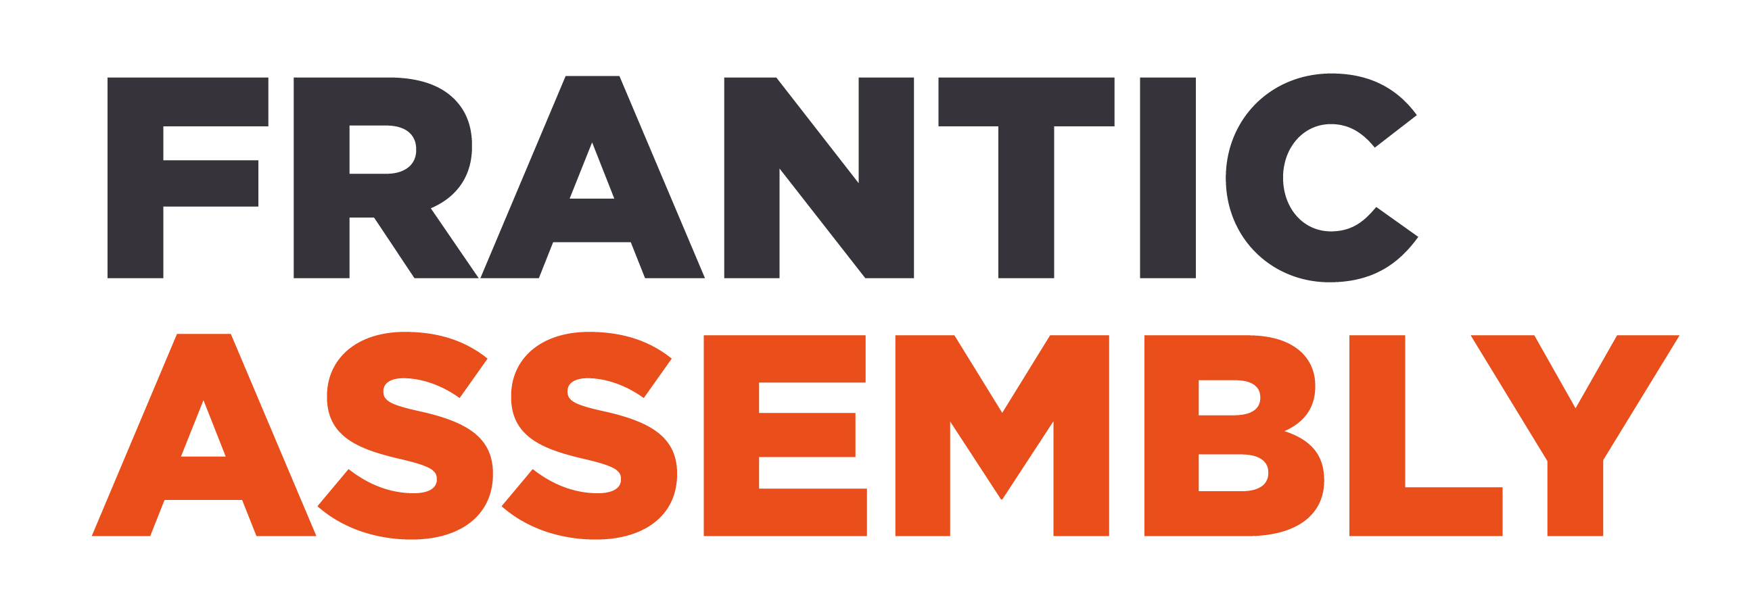
Award winning theatre company Frantic Assembly’s method of devising theatre has been impacting theatrical practice and unlocking the creative potential of future theatre-makers for up to 22 years. One of the most exciting theatre companies in the UK, Frantic Assembly is led by Artistic Director and co-founder Scott Graham, and has toured extensively across Great Britain, and worked in 40 countries internationally collaborating with some of today’s most inspiring artists.

Frantic Assembly is currently studied as leading contemporary theatre practitioners on five British and international academic syllabuses. The success of the company’s distinct approach has influenced contemporary theatre-making and foregrounded the use of movement directors and choreographers in new dramatic works. With a history of commissioning writers such as Mark Ravenhill, Abi Morgan, Simon Stephens and Bryony Lavery the company has been acclaimed for it’s collaborative approach. In 2016 the company started delivering practical modules on a new Collaborative Theatre-Making MA it has created with Coventry University (UK Modern University of the Year 2014, 2015, 2016 and UK University of the Year 2015). Frantic Assembly runs Ignition, a free national training programme for young men aged 16-20, increasing involvement in and access to the arts in places of low cultural engagement.

Frantic Assembly productions include Othello, Beautiful Burnout (UK, Australia, New Zealand and New York), Lovesong, (Stockholm, UK and Australia), The Believers, Fatherland (Manchester International Festival 2017 and Lyric Hammersmith 25 May-23 June 2018). They are also the Movement Directors on the award-winning National Theatre of Great Britain, production The Curious Incident of the Dog in the Night-Time (West End, Broadway, UK & Ireland Tour). Television credits include Movement Direction on BAFTA winning British - American series Humans (AMC, Channel 4 & Kudos).

Frantic Assembly is supported by the National Lottery through Arts Council England
www.franticassembly.co.uk
@franticassembly

About Theatre Royal Plymouth
Theatre Royal Plymouth specialises in the production of new plays alongside the presentation of a broad range of theatre - including classic and contemporary drama, musicals, opera, ballet and dance. They have three performance spaces – The Lyric, The Drum and The Lab. Their work with young people and communities is extensive and radical, taking place across all three venues and beyond.
Recent Theatre Royal Plymouth productions include: 49 Donkeys by Carl Grose, Clockwork Canaries by Christopher William Hill, The Here and This and Now by Glenn Waldron, The War Has Not Yet Started by Mikhail Durnenkov, Monster Raving Loony by James Graham, The Man With The Hammer by Phil Porter, The Whipping Man by Matthew Lopez, After Electra by April de Angelis, Grand Guignol and Horse Piss for Blood by Carl Grose, Another Place by DC Moore, The Astronaut’s Chair by Rona Munro, and MAD MAN by Chris Goode.
The Theatre Royal Plymouth also collaborates with some of the best artists and theatre makers in the UK and internationally. They have regularly co-produced with long standing partners Ontroerend Goed (£Y€$, Audience, World Without Us, A History of Everything, Sirens, Fight Night)) Paines Plough (The Angry Brigade by James Graham, Love Love Love by Mike Bartlett), Told By An Idiot (My Perfect Mind, And The Horse You Rode In On, Napoleon Disrobed), Graeae (The Solid Life of Sugar Water by Jack Thorne) and with Frantic Assembly (Othello, The Believers by Bryony Lavery, Lovesong by Abi Morgan).

