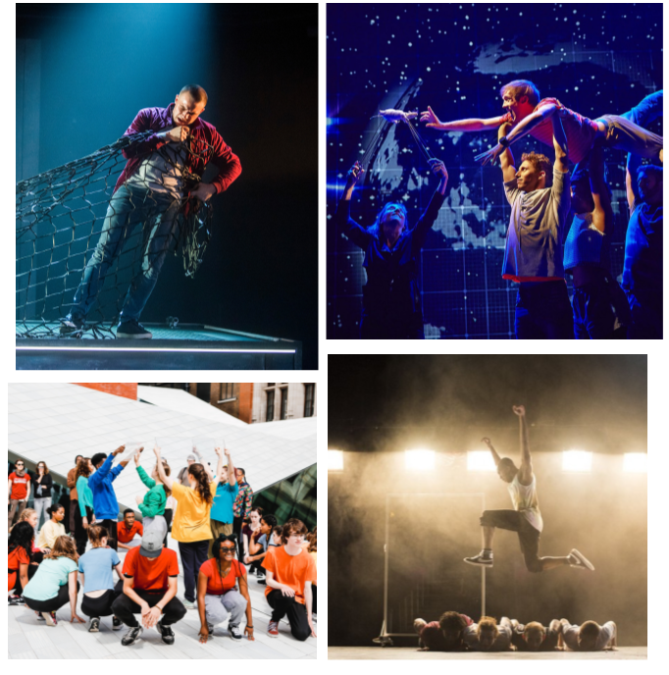
“The vibrant and visceral Frantic Assembly" INDEPENDENT

TRAINEE PRACTITIONER (FEMALE)
APPLICATION PACK
TRAINEE PRACTITIONER (FEMALE)
APPLICATION PACK

Thank you for your interest in the post of Trainee Practitioner at Frantic Assembly. If you require this pack or the application form in an alternative format, please contact us on 020 7841 3115 or email recruitment@franticassembly.co.uk.

The contents of this pack include:
- a job description
- a person specification
- guidance for applicants
- information about the company

How to Apply

To apply, please complete the application form and the equal opportunities monitoring information. Please set out what skills and experience you would bring to Frantic Assembly and why the job interests you.

The deadline for applications is: Midday on Friday 13th December

﻿We will contact every applicant to inform them whether they have been shortlisted or not by 20th December.

Please specify whether you would like to attend a recruitment workshop on Friday 3rd OR Saturday 4th January.

If you would like to apply via email, please contact recruitment@franticassembly.co.uk for a downloadable version of the application form.

Please mark your email TRAINEE PRACTITIONER APPLICATION

To find out more about the role please contact Marilyn Rice on 020 7841 3115 or email marilyn@franticassembly.co.uk We look forward to hearing from you.

Frantic Assembly believes theatre is an activity for all and promotes diversity and access across all of its activities. We welcome and encourage applicants from all backgrounds to apply and are particularly keen to hear from candidates under-represented in the Arts.

This role is advertised to female candidates or those identifying as female only, under Section 159 of the Equality Act of 2010: we are taking a protected characteristic into consideration when deciding whom to recruit to address under-representation of women in our freelance practitioners.

FRANTIC ASSEMBLY TRAINEE LEARN PRACTITIONER

Frantic Assembly is seeking to appoint up to three creative and committed female or female identifying practitioners to become our Trainee Practitioners. This is a fantastic professional development opportunity to work closely with the company, to join our pool of freelance practitioners and support the delivery of Frantic Assembly’s Learn and Train activities, including our spring workshop programme.

Our freelance practitioners are integral to the company and deliver all of Frantic Assembly’s workshops and residencies in schools, colleges and universities in the UK and internationally.

Trainee Practitioners will undertake five-week training positions, receiving mentoring and skills training from Scott Graham, Frantic Assembly’s Artistic Director and/or Simon Pittman, Associate Director (Learn and Train).

The ideal candidates will demonstrate a passion for delivering high-quality participatory arts activities for young people and strong potential as a workshop leader in theatre making, physicality and devising. We are looking for candidates who have previous experience and a desire to make their own work.

The successful applicants will be required to work in various locations across the UK and will need to undertake a full DBS check.

Salary and schedule:
DATE | TIME | Activity | FEE
Monday 27 - Friday 31 January | 10am- 5pm | Training intensive | £375
Monday 03 - Friday 07 February | 10am- 5pm | Training intensive | £375
Monday 10 - Friday 14 February | 9am- 4pm | Workshop week one | £375
Monday 17- Friday 21 February | 9am- 4pm | Workshop week two | £375
Monday 24 - Friday 28 February | 9am- 4pm | Workshop week three | £375

*This will also be followed up by a three-week contract as a trained practitioner at a weekly rate of £650
*Expenses will be covered for Travel and accommodation costs for work outside of London.
Hours of work: Maximum of 40 hours per week, which may involve evening and weekend work and travel away from home.

Location: The successful applicant must be prepared to travel on a daily basis.

Shortlisted candidates will be invited to a 3-hour practical workshop. Workshops will be held in London on either Friday 3rd or Saturday 4th January from 10:30am-1:30pm.

Interviews will take place on Tuesday 7th and Wednesday 8th January

Training will be made up of:

- Part One- Two Intensive Training weeks with the Associate Director (Learn & Train) during the weeks commencing Monday 27th January- Friday 7th February 2020.
- Part Two
- Observing, supporting and shadowing practitioners in Learn and Train workshops Monday 10th February to Friday 29th February 2020.
- Part three- a three-week contract as a trained practitioner leading on Learn and Train workshops (dates TBC).

Job Description

The Frantic Assembly Trainee Practitioner will be responsible to the Artistic Director, Head of Learning & Participation and the Associate Director (Learn & Train) and will follow the activity patterns as set out by the company on a weekly basis.

Tasks and responsibilities include:
- Taking part in practitioner training workshops led by the Artistic Director and/or Associate Director (Learn & Train).
- Undertaking in-house training delivered by the Head of Learning & Participation in areas of child protection and best practice for working with schools and diverse groups.
- Supporting / co-leading workshops delivered by Frantic Assembly Practitioners in schools and colleges around the UK, building towards delivering workshops at the end of the traineeship
- Co-leading on residencies in schools, colleges & universities
- Adhering to Frantic Assembly’s Safeguarding Policy, Equal Opportunities Policy, Data Protection, and Health and Safety Policy at all times when representing the company.

Person Specification

Essential skills
- A minimum of two years experience of professional theatre practice
- Experience of collaborative theatre-making, and a desire to make theatre
- An interest and aptitude for movement and physicality
- A passion for engaging young people and communities in the arts
- Experience of running theatre workshops with young people.
- Excellent communication skills
- Strong organisational and time management skills
- Ability to work on your own initiative and as part of a small, committed team
- A positive, friendly and professional attitude
- A love of contemporary arts and culture and theatre in particular

Desirable skills
- Experience of working with community and outreach groups
- Some understanding of safeguarding practice
- Experience or training in any of the following: theatre direction, movement direction, dance or choreography
- Experience of working with disadvantaged young people

TO APPLY

To apply for this role, please complete:
- this application form
- this monitoring form for equal opportunities

Please note that the application form does not have a save function. For the personal statement section, you are able to cut and paste from a word document.

Guidance notes for applicants

How Frantic recruit

You will be marked on the information you provide within your application form, your performance in the workshops and in your interview only. We will not be assessing you based on existing knowledge of your professional experience that we might have.

It is therefore important to remember that those involved in the selection process cannot guess or make assumptions about you. Make sure you tell us everything relevant to your application and that you complete all the sections on the form.

These notes are intended to help you to participate in our selection process as effectively as possible and assist you in providing us with all the information that we need to help us understand how you meet the requirements of the role. Please read these notes carefully before completing your application form.

Examine the Job Description and Person Specification
The job vacancy includes a full job description with a person specification. The purpose and main duties and responsibilities of the post are set out in the job description and the knowledge, skills and experience we are looking for in the successful candidate are listed in the person specification. It is important to read all the information in these documents before completing your application.

Analyse your experience
Look at the activities involved in the vacancy. Ask yourself why you are interested in this vacancy? Would it be a good career move for you? Is the move a promotion, which would enable you to gain more responsibility or enhance your skills, or is it a sideways move intended to broaden your skills and experience? Think about what evidence you can provide to demonstrate you have the necessary knowledge, skills and experience.

Completing the Form
If you require an application form in an alternative format please contact us on 020 7841 3115. Please do not attach any additional information to your application form. CVs will not be considered.

The section headed ‘Supporting Information for Application’ is a very important part of the form. This is your opportunity to tell us specifically why you wish to apply for the vacancy and what makes you a suitable applicant. It is important that you provide us with evidence to demonstrate that you possess the knowledge, skills and experience required as set out in the person specification for the role. It is not sufficient to merely state in your application that you have the knowledge, skills or experience required. Provide specific examples of what you have done and how you believe this demonstrates you meet each requirement.

Don’t forget to proof-read your form and check for any errors before submitting it to us.

Application Form marking system
Your application form forms part of the assessment process and you will be marked on both your application form, workshop and your interview. When marking we are assessing how closely your application meets the selection criteria set out in the person specification. We will go through your application in detail looking for specific evidence that you possess the knowledge, skills and experience required for the role. Unless you have provided specific evidence, supported by relevant examples, you are unlikely to score highly.

Interviews
We will contact you by phone to invite you to interview followed by an email. This email will give full details of what the selection process will involve. This may include carrying out a selection exercise to test out your ability to carry out specific requirements of the role for which you have applied.

Offers
All offers are made subject to receipt of satisfactory references, proof of identity, address and eligibility to work in the UK. You will be required to undertake an enhanced DBS check.

We hope you find the above helpful and good luck with your application.

About Frantic Assembly

Frantic Assembly creates thrilling, energetic and unforgettable theatre (“the most innovative and progressive theatre company around” The Times).

Led by founding Artistic Director Scott Graham the company attracts new and young audiences with work that reflects contemporary culture. Vivid and dynamic, with a unique physical style, the company has built a reputation as one of the most exciting companies in the country. Frantic Assembly has toured widely throughout the UK, since its inception in 1994 and has performed, created and collaborated in 40 countries internationally.

Frantic Assembly collaborates with many of the UK’s leading artists, regularly commissioning writers to create original works for the stage. In past productions we have worked with playwrights Simon Stephens, Andrew Bovell, Mark Ravenhill, Abi Morgan and Bryony Lavery. Our distinct creative approach has influenced contemporary theatre-making and prioritised the use of movement directors and choreographers in new dramatic works. It has inspired writers to embrace new creative processes and opened up actors and dancers to new techniques. This is a matter of great pride as we continue to do something different and to do it differently.

Sharing our work and the way we work is at the heart of what we do. The accessibility of the Frantic Method has empowered and inspired people to participate, educate, collaborate and make thrilling work. Our learning and participation work is therefore symbiotic with and emanates from our artistic output. Our performances fire people up to attend Frantic Assembly workshop, which in turn creates new and diverse audiences for our show and the wider theatre industry.

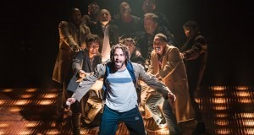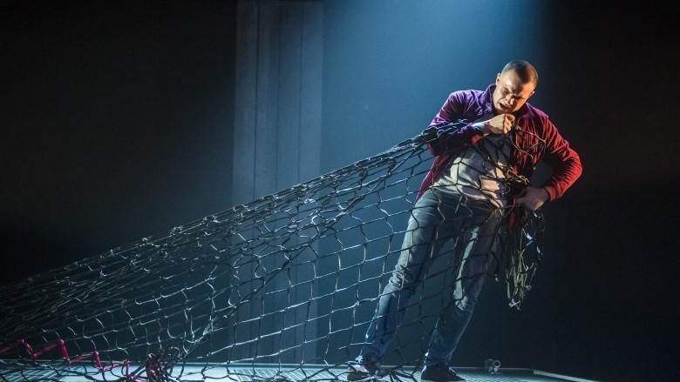
Fatherland The Unreturning

Our Learn & Train activity currently encompasses four key programmes:
- Our Learn workshops for students. We are studied as leading contemporary theatre practitioners on five British and international academic syllabuses. We work with schools in the UK and abroad, including touring workshops and residences to Asia, America, Canada and Australia.
- Our Train workshops for emerging artists, practitioners, and teachers. Our introductory, intermediate and advanced workshops draw participants from all over the world.
- Ignition; our ground breaking, innovative vocational training project for young men. Targeting those with little previous experience of or exposure to the arts, Ignition engages the least engaged and unlocks creative potential in boys across the UK.
- A Collaborative Theatre-Making MA delivered with Coventry University.

Productions

PRODUCTION | WRITER | YEAR | TOURING
The Unreturning | Anna Jordan | 2018/2019 | UK
Fatherland | Scott Graham, Karl Hyde and Simon Stephens | 2017/2018 | UK
This Will All Be Gone | Devised by the company | 2017 | ASIA
Things I Know to Be True | Andrew Bovell | 2016/2017/2018 | AUSTRALIA  UK
No Way Back | Scott Graham, Neil Bettles and the company | 2015 | UK
The Believers | Bryony Lavery | 2014 | UK
Little Dogs | Scott Graham and Steven Hoggett | 2012 | UK
Lovesong | Abi Morgan | 2011 | UK
Beautiful Burnout | Bryony Lavery | 2010/2011/2012 | UK, AMERICA, AUSTRALIA, NEW ZEALAND
Othello | William Shakespeare | 2008/2014/2015 | UK
Stockholm | Bryony Lavery | 2007/2008 | UK
pool (no water) | Mark Ravenhill | 2006 | UK
Dirty Wonderland | Michael Wynne | 2005 | UK
On Blindness | Glyn Cannon | 2004 | UK
Rabbit | Brendan Cowell | 2003 | UK
Peepshow | Isabel Wright | 2002 | UK
Heavenly | Scott Graham, Steven Hoggett and Liam Steel | 2002 | UK
Tiny Dynamite | Abi Morgan | 2001 | UK
Underworld | Nicola McCartney | 2000 | UK
Hymns | Chris O'Connell | 1999/2000/2005 | UK
Sell Out | Michael Wynne | 1998 | UK
Zero | Devised by the company | 1997 | UK
Flesh | Spencer Hazel | 1996 | UK
Klub | Spencer Hazel | 1995 | UK
Look Back In Anger | John Osborne | 1994 | UK

The Company

Artistic Director Scott Graham
Executive Director Kerry Whelan

Producer Peter Holland

General Manager Angie Fullman
Administrator Vicky Olusanya

Head of Learning & Participation Marilyn Rice
(Maternity Cover)
Head of Learning & Participation Sharon Kanolik
(Maternity Leave)
Associate Director (Learn & Train) Simon Pittman
Learning & Participation Coordinator Maya Pindar
Learn & Train Project Manager Alisha Artry

Board
Sian Alexander (Chair), Amit Kataria, Tina Kokkinos, Matthew Littleford, Sally Noonan and Joanna Read.

Practitioners
Maggie Ann Bain, Amelia Cardwell, Michelle Edwards, David Gilbert, Paolo Guidi, Sean Hollands, Richard James Neale, Perry Johnson, Steve Kirkham, Vicki Manderson, Gavin Maxwell, Steven Miller, Felipe Pacheco, Marc Pouani, Jonnie Riordan,
Naomi Said, Sophie Shaw, Krista Vuori, Jess Williams.

Thanks for your interest – we look forward to hearing from you.

